

Religious Trust and Endowments Department, Madhya Pradesh

System Requirement Specification

Version – 2.2



M.P. State Electronics Development Corporation Ltd. A Government of MP Undertaking

Document Control
References related to Document
Date | Source | Version | Remarks
3.4.2021 | In discussion with department | 1.0
10.08.21 | In discussion with department | 1.1
08.04.2022 | In discussion with department | 2.0
13.06.2022 | Discussion with PS Sir | 2.1
24.06.2022 | As per the discussion with Department | 2.2

Document Release Note Document Details
Name | Version | Description
SRS Document | 1.0 | Approval process with content management system
SRS Document | 1.1 | Field added as per the suggestion by PS Sir
SRS Document | 2.0 | Changes in temple and temple property information
SRS Document | 2.1 | New field added in temple information and temple property information form
SRS Document | 2.2 | Add new fields in temple information form and change the functionality of adding income/expenses details

Table of Content

Table of Contents
- Client’s background and Area of Operation 3
- Overview of the existing system 3
- Project Objective 3
- Scope of the project 3
- Stake Holder 3
- User Interface 4
- Functional Requirements 4
- Overall Process flow 5
- Use Cases 6
- Non – Functional Requirement 6
- Forms/Reports/Screens 7
  - Forms 8
  - Screens 14

- Client’s background and Area of Operation
Religious Trust and Endowment Department (Dharmik Nyas Evam Dharmasva Department) was formed as a separate department on 1-7-1981 to look after the works under religious institutions and religious trusts. The work of this department is done by the Collector at the district level.
In the records of Government maintained temples and the land attached with them, the name of collector has been registered as administrator, with the name of land owner who is idol itself.
- Overview of the existing system
Existing system does not provide the data approval process, it’s also not cover the cms functionalities, department needs to rely on existing system manager for every single file uploading.
Now we are creating a system which can be manage by department itself and if department want to change any contents available on website they can change easily.
- Project Objective
Department has required information about governed temple for which an online form should be provided to the collector office and sub-divisional officers.
Using login id and password (provided by Adhyatm Department) all the temple related information (as prescribed format) should be submitted by authorized persons (sub-divisional officers) so that admin/spiritual department came to know different source of income of temple/temples also department get to know all the property (movable property and non-movable property) attached with the temple and total income of temple.
- Scope of the project

Current scope is defined to get temple’s information from all governed temples. This information will be approved by collectors/competent authority.

- Stakeholders
Type of user available –

⇒ Department (HO)
⇒ District

- User Interfaces
- Interface, to get details about temples related information at District Level Login.
- To view all the temples related information at department (HO) login (updated by district level users).

- Functional Requirements Web Application -

Sr. No | Requirement ID | Requirement Description
1 | FR-01 | System should display landing page.
2 | FR-02 | System should display a login option on portal
3 | FR-03 | System should display username field.
4 | FR-04 | System should display password field.
5 | FR-05 | System should display login button.
6 | FR-06 | System should verify the type of users.
7 | FR-07 | If user is admin user, then system should allow to see all the temple and pujari related information.
8 | FR-08 | If user login as District User, then system should allow to enter all the temple related information.

- Overall Process flow
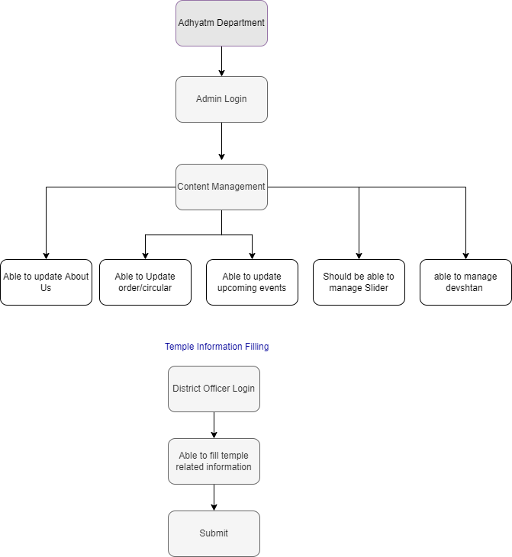

- Use Cases

- Department/Admin Login
- District Agency
- District Nodal Officer

Name of Use Case: | Department/Admin Login
Description: | Using department/admin login user will be able to manage web site content.
User: | Admin
Preconditions: | - User should be authorized user  - User should be logged in with valid credential
User Action: | - User will get option for login on mandir darpan application.  - Authorized user logs in using provided credentials.  - If system fail to validate user, then should be show an error message.  - User can view the verification status (verified/not verified) of temple information, pujari information, property information,  income information.
Post conditions: | NIL

Name of Use Case: | District Login (Agency User)
Description: | Using district agency login user will be able to add temple information.
User: | District Level
Preconditions: | - User should be authorized user  - User should be logged in with valid credential.
User Action: | - User will get option for login on mandir darpan application.  - Authorized user logged in using provided credentials.  - After successful login, user can enter temple information, pujari information, property information, income information.  - This information will be available at district nodal officer level for verification and at admin level for review.  - Agency user can also update the unverified information if required by district nodal officer.
Post conditions: | NIL

Name of Use Case: | District Login (Nodal Officer)
Description: | Using district admin user will be able to approve/update temple information.
User: | District Level
Preconditions: | - User should be authorized user  - User should be logged in with valid credential.
User Action: | - User will get option for login on mandir darpan application.  - Authorized user logged in using provided credentials.  - After successful login, user will be able to approve/edit temple information, pujari information, property information, income  information which have been entered by agency users.
Post conditions: | NIL

- Non – Functional Requirement

- API Integration (for Samagra Id and Land records).
- System should fetch maximum pujari personal information using Samagra id.
- System has the option for download reports in excel format at admin and district nodal officers.
- The system should maintain the log for Add/Update history.
- The system should show update history for every admin/district user login.

- Forms /Screens
  - Forms –

Temple Information –

Sr.  No. | Form Field | Field Type | Data Type | Control Type | Dependency | Mandatory  / Optional | Acceptance | Remarks
1 | Temple  Classification | Dropdown | Integer | Select |  | Mandatory
Temple classification master - 'kklu }kjk la/kkfjr eafnj, yksd U;kl vf/kfu;e-1951 ds varxZr पंजीबद्ध eafnj( ifēyd /kkfeZd VªLV vk/kkfjr eafnj,
औकॉफ }kjk iathÑr मंदिर जजसकी व्यवस्था शासन }kjk dh tkrh gS , vU; dksbZ Hkh eafnj tks 'kklu द्वारा la/kkfjr gks
2 | Name of temple | Textbox | Varchar | Input |  | Mandatory
3 | chief god | Textbox | Varchar | Input |  | Mandatory
4 | Name of the Chairman of Temple Management Committee / Working Trustee | Textbox | Varchar | Input
5 | Name of Secretary / Manager / Administrator of Temple Management Committee / Working Trustee | Text Area | Varchar | Input
 | Temple Opening Time
 | Temple Closing Time
6 | Number entered in the apology  aucof register | Textbox | Alphanumeric | Input |  | Mandatory
7 | Address | Text Area | Varchar | Input
8 | District | Dropdown | Integer | Selection |  | Mandatory
9 | Tehsil | Dropdown | Integer | Selection | based on  district | Mandatory
 | Gram  Panchayat | Dropdown | Integer | Selection | based on tehsil | Mandatory
10 | Village | Dropdown | Integer | Selection | based on gram  panchayat | Mandatory
11 | Ward no. | Textbox | numeric | Input

12 | Pin Code | Textbox | numeric | Input |  | Mandatory | 6 digits only
 | Landmark
13 | Bank Account  No. | Number (30) | Integer | Input
14 | IFSC Code | Textbox | Alphanumeric | Input
15 | Bank Branch | Textbox | Varchar | Auto | Auto based on IFSC code
16 | Bank Name | Textbox | Varchar | Auto | Auto based on IFSC code
17 | Photos of temple | Browse | Image (jpg) | Upload |  |  | Multiple photos can be added (Size 5MB/Photo) Auto optimize image size 1MB | Rightside1 Rightside2 Leftside1 Leftside2 Front View 1  Front View 2  Backside 1  Backside 1  All above are mandatory Commercial activity (Optional) Agricultural land  (Optional)
18 | General and historical information about the temple | Text area |  | Input
19 | GPS Location | Textbox | Alphanumeric | Auto |  |  |  | Based on GIS Integration
20 | Last Updated on |  |  | Auto |  |  | Current date and time

Pujari Information -

Sr.  No. | Form Field | Field Type | Data Type | Control  Type | Dependency | Mandatory  / Optional | Acceptance | Remarks
1 | Samagra Id | Textbox | Integer | Input |  | Mandatory
2 | Pujari Name | Textbox |  | Auto | Based on  samagra Id
3 | Fathers Name | Textbox |  | Auto | Based on samagra Id
4 | Date of Birth | Textbox |  | Auto | Based on  samagra Id
5 | District | Textbox |  | Auto | Based on samagra Id |  |  | district_id
6 | Local Body | Textbox |  | Auto | Based on samagra Id
7 | Gram  Panchayat/Zone | Textbox |  | Auto | Based on  samagra Id
8 | Village/Ward | Textbox |  | Auto | Based on

 |  |  |  |  | samagra Id
9 | Pin Code | Textbox |  | Auto | Based on samagra Id |  |  | pin_code
10 | Vidhan Sabha Kshetra | Dropdown | Integer | Select | Populate records Based on selected  district | Mandatory
11 | Mobile No. | Textbox | Integer | Input |  | Mandatory
12 | Bank Account No. | Textbox | Integer | Input |  | Mandatory
13 | IFSC Code | Textbox | Varchar | Input |  | Mandatory
14 | Name of the bank | Textbox | Varchar | auto |  | Based on IFSC Code
15 | Bank Branch | Textbox | Varchar | auto |  | Based on IFSC Code
16 | Pujari Appointment  Order No. | Textbox | Varchar | Input |  | Mandatory
17 | Order Date | Textbox | Date | Input |  | Mandatory
18 | Monthly Wages | Decimal  (6,2)
19 | Appointing  Officer’s Name | Textbox | Varchar | Input |  | Optional
20 | Upload Order | Browse |  | Select |  | Optional
21 | Upload Pujari color  Photo | Browse |  | Select
22 | Last Updated date |  |  | auto
Note: 1. Multiple records can be added
2.All the fields which is fetched by samagra id should not be editable

Temple Land Details (मंदिर की भूमम का वििरण)

Sr.  No. | Form Field | Field Type | Data Type | Control  Type | Dependency | Mandatory  / Optional | Acceptance | Remarks
1 | District | Dropdown
2 | Tehsil | Dropdown
3 | Area of land | Dropdown | Integer | Select |  |  | Urban / Rural  / Forest
4 | Khasra No. | Textbox | alphanumeric | Input |  | Mandatory |  | Multiple khasra can  be added
5 | Name of the land holder in the  records | Textbox | Varchar | Auto | Based on khasra |  | Rural/Urban
6 | Patwari’s Halka  Name | Textbox | Varchar

5 | Patwari Halka No. | Textbox | alphanumeric | Input
6 | Total Land Area | Textbox | alphanumeric | Auto | Based on khasra |  |  | Total land area will be calculated by adding multiple land  area
7 | Temple Built up area | Textbox | Numeric | Input
8 | Temple open  area (area) | Textbox | Numeric | Input

Temple Property and Income/Expenses –

Sr.  No. | Form Field | Field Type | Data  Type | Control  Type | Dependency | Mandatory  / Optional | Acceptance | Remarks
1 | Financial year | Drop-down |  |  |  |  | Default current year
2 | Total Average monthly  Income (in rupees)
3 | Color photo of donation box | Upload
Statement of Income from Immovable Property (अचल संपत्ति से प्राप्त आय का त्तििरण)
4 | Immovable Property | Auto from master
5 | Count (संख्या) | Textbox
6 | Total Construction/Area of Land  (In square meters) | Textbox
7 | Monthly/Yearly | dropdown |  |  |  |  | 1. Monthly 2. Yearly
8 | Amount of total income (in Rs.) | Textbox
9 | Total Income | Auto |  |  |  |  | Sum of (Amount of total income)
Movable Property Details (चल संपत्ति का त्तििरण)
10 | Name of the Movable Property | Auto from Master
11 | Description | Text area
12 | Amount of total income (in Rs.) | Textbox
13 | Total Income | Auto |  |  |  |  | Sum of (Amount of total income)
Details of income received from other activities (अन्य गततत्तिधियो से प्राप्त आय का त्तििरण)
14 | Name of the activity
15 | Income (Yearly)
16 | Total Income | Auto |  |  |  |  | Sum of yearly income

Details of expenses
17 | Total Average Annual Income (in Rs.) | Text box
Details of expenditure for various activities (जवजिन्न गजिजवजियो के O;; का जववरण)
18 | Name of the Activity | Auto from Master
19 | Expenditure Monthly/Yearly | dropdown |  |  |  |  | 1. Monthly 2. Yearly
20 | Amount of Expenditure (in Rs.) | Textbox
21 | Total Average Annual Expenditure | Auto |  |  |  |  | Sum of (Amount of  Expenditure)
Note: Digital color photographs (jpg format, and size not more than 1 MB)

  - Screens –

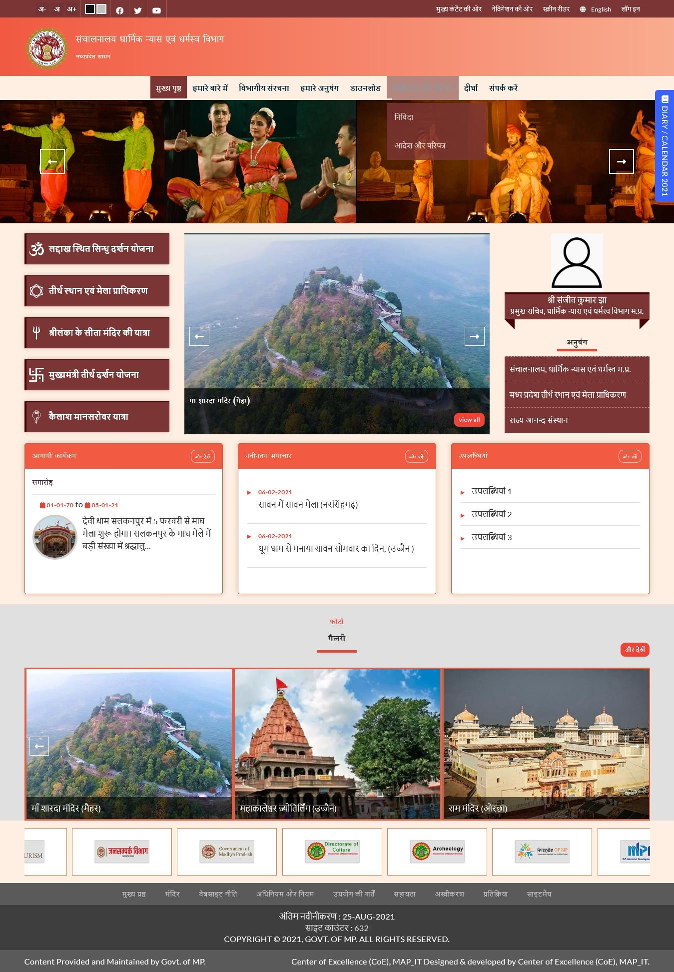

- Reports
- Temples Details Information Report
- Temples Land Information
- Pujari/Priest Information Report
- Income and Property of Temples Information
Filters Parameters - Temple Category, District, City/Village, Temple Name, Pujari/Priest, Land Area Type,

